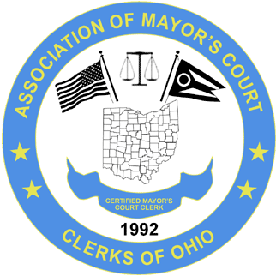
ASSOCIATION OF MAYOR’S COURT CLERKS OF OHIO
(A.M.C.C.O.)
www.ohiomayorscourtclerks.org

BOARD MEETING – FALL CONFERENCE- MOHICAN STATE PARK LODGE AND CONFERENCE CENTER - PERRYSVILLE, OHIO – SEPTEMBER 18, 2019

President Ja’net Crawford welcomed everyone and called the meeting to order at 6:06 p.m.
ATTENDEES:
Ja’net Crawford, President, Montgomery Kathi Cole, NE rep., North Olmsted
Rebecca Rosenbalm, Secretary, Monroe Robin Kemp, SW rep, Amberley Village
Joy Bedard, Past President, Grove City Kathy Kaluger, SE rep, St. Clairsville
Amanda Parker, Vice President, Gahanna Linda Lutts, Education Committee Chair,
Sharonville
Absent: Molly Schwartz, CE rep, Pickerington & Karen Goaziou, NW rep, Put in Bay and Marcia Soos, Treasurer, Shadyside
OLD BUSINESS:
Secretary Becky Rosenbalm presented the board meeting minutes from the spring conference, dated April 24, 2019. No additions or corrections were made to the meeting minutes. Robin Kemp motioned to approve the minutes with a second from Kathy Kaluger. The minutes were approved.
Kathy Kaluger presented the treasurer’s Report in the absence of Marcia Soos. The Report showed an ending balance of $28596.31. Robin Kemp motioned to approve the treasurer’s report with a second by Kathi Cole.
Linda Lutts presented the Education Committee Report. The spring 2020 conference will be held at the Quest Conference Center on April 30 and May 1, 2020. 8405 Pulsar Place, Columbus, Ohio 43240. Lodging will be on your own. There is a Hampton Inn within walking distance to the conference center. We need ideas for locations/speakers for the fall 2020 conference.
The Ohio Municipal League reached back out to Linda and are interested in assisting us with our conferences. We will schedule a meeting with them either late 2019 or early 2020. They have said they will make certificates for attendees and our only cost would be their expenses.
After much discussion it was determined that we will now refer to our Spring Conference as a Professional Development Program and Core Refresher. This will take the place of the New Clerk Training. Clerks already certified will be grandfathered in as certified. If you have enough points in April of 2020 under the old point system, you will be certified in April. Once you have one spring conference you will become certified.
We will try to hold the fall 2020 conference in the NW Region and it may be the third week of September.
NEW BUSINESS:
There was open discussion regarding the website and the new look that has been created. It was voted that it would be okay to have the company go ahead and switch over to the new look and disable the old website look. We will try to schedule another phone conference with Brian White from Web Hosting Solutions to see what functionality is available to update the website moving forward.
With nothing further a motion to adjourn the meeting was requested by Kathi Cole with a second by Amanda Parker. The meeting adjourned to assemble conference packets at 7:44 p.m.

Respectfully submitted,

Rebecca Rosenbalm
Secretary

