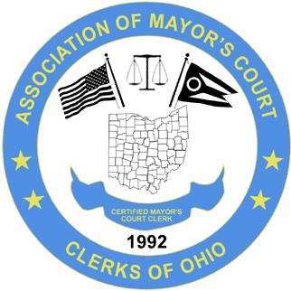

ASSOCIATION OF MAYOR’S COURT CLERKS OF OHIO
www.ohiomayorscourtclerks.org
SPRING SEMINAR APRIL 27 – 28, 2023
Embassy Suites by Hilton Columbus Airport
2886 Airport Drive
Columbus, OH 43219
(614) 536-0500

REGISTRATION INFORMATION

NAME: ________________________________________________________________________

COURT: _______________________________________________ REGION: __________

ADDRESS: _____________________________________________________________________

CITY: ____________________________________ STATE: __________ ZIP: ______________

TELEPHONE: ____________________________________ FAX: __________________________

EMAIL: ________________________________________________________________________

REGISTRATION DEADLINE: April 13, 2023

____ Active Member $200

____ Non Member $300

Make checks payable to: A.M.C.C.O.

Send registration payment to: MONTGOMERY MAYOR’S COURT
JA’NET CRAWFORD
10150 MONTGOMERY RD
MONTGOMERY, OH 45242
jcrawford@montgomeryohio.org
513-985-1606

