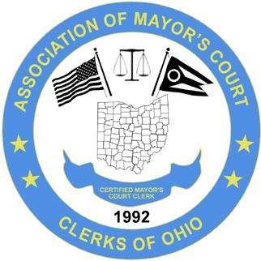April 26-28, 2023 – Embassy Suites Airport-Columbus
The Association of Mayor’s Court Clerks of Ohio
2023 Spring Conference
____________________________________________________________________________________________
AGENDA
WEDNESDAY APRIL 26
6:00 P.M. Board Meeting – Upper Arlington

April 26-28, 2023 – Embassy Suites Airport- Columbus
The Association of Mayor’s Court Clerks of Ohio
2023 Spring Conference
___________________________________________________________________________________________
AGENDA
THURSDAY APRIL 27

7:30 A.M. Breakfast & Networking – New Albany Ballroom
8:30 A.M. New Clerks Meeting – New Albany Ballroom

8:30 A.M. Welcome

8:45 A.M. Business Meeting
9:00 A.M. Sealing
Melanie Tobias

9:45 A.M. Break/Visit Vendors - Foyer
10:00 A.M. SB 288
Frost Brown Todd

10:30 A.M. Budget Building

11:30 A.M. Lunch - Atrium
1:00 P.M. OPERS

2:00 P.M. Break

2:30 P.M. Supreme Court Tour – BUSES LEAVE AT 2:30 P.M. & TOUR STARTS AT 3:15 P.M.

5:00 P.M. Return to Embassy Suites

April 26-28, 2023 – Embassy Suites Airport- Columbus
The Association of Mayor’s Court Clerks of Ohio
2023 Spring Conference
___________________________________________________________________________________________

FRIDAY APRIL 28
7:30 A.M. Breakfast & Networking
8:30 A.M. Welcome

8:30 A.M. “Overcoming Obstacles”
Niki Hampton

10:00 A.M. Break/Visit Vendors - Foyer

10:30 A.M. “You can COME BACK”
Niki Hampton

11:45 A.M. Closing Statement

