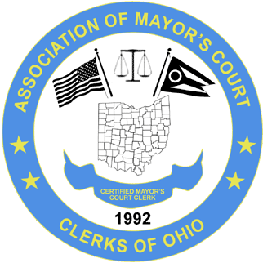
ASSOCIATION OF MAYOR’S COURT CLERKS OF OHIO
(A.M.C.C.O.)
www.ohiomayorscourtclerks.org

BOARD MEETING – SPRING CONFERENCE – EMBASSY SUITES – COLUMBUS, AIRPORT- APRIL 26, 2023
President Sonja Morrow called the meeting to order at 6:13 p.m.
ATTENDEES:
Sonja Morrow, President, North Ridgeville Kristy Thome, SW rep., Enon
Sarah Osborn, Vice President, Piketon Julie Stelzer, NW rep., Milan
Amanda Parker, Past President, Gahanna Pam Parrill, SE rep., Frazeysburg
Becky Rosenbalm, Secretary, Monroe Ja’net Crawford, Treasurer, Montgomery

Absent : Molly Schwartz, CE rep., Pickerington and NE rep. position is vacant.

Secretary Becky Rosenbalm presented the board meeting minutes from the 2022 Fall conference dated September 21, 2022. No additions or corrections to the minutes were noted. A motion to approve the minutes was requested by Ja’net Crawford with a second by Julie Stelzer.
Treasurer Ja’net Crawford presented the Treasurer’s Report. The report showed an ending balance of 78644.32. Ja’net mentioned that there was only one refund request, and the City in question requested the registration be moved to the Fall Conference. Julie Stelzer requested a motion to move the Spring registration fee to the Fall for this agency, with a second by Kristy Thome. The fee will be carried forward. A motion to approve the Treasurer’s Report was requested by Sonja Morrow with a second by Kristy Thome.
OLD BUSINESS:
A contract for the 2023 Fall Conference has been signed with Embassy Suites. The conference will be held in the same location as the Spring. Rooms will be $136.00 a night. There will be 50 rooms reserved for Wednesday, September 20, 2023 and 65 rooms for Thursday, September 21, 2023. Conference dates are Thursday and Friday, September 21 and 22, 2023.

NEW BUSINESS:
Ja’net advised the Education Committee received a request from Anthony Gomez of Cuyahoga Falls to join the Education Committee. Ja’net requested a motion to add Anthony as a new member of the Committee, and the entire board approved.
Our Fall 2024 Conference is scheduled to be held in the SW region. More information regarding that to follow.
With nothing further a motion to adjourn the meeting was requested by Ja’net Crawford with a second by Kristy Thome. Meeting was adjourned at 7:50 p.m.

Respectfully submitted,

Rebecca Rosenbalm
Secretary, AMCCO

