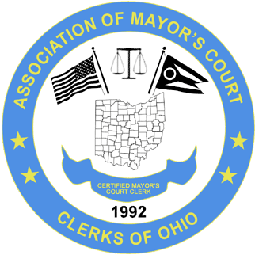
ASSOCIATION OF MAYOR’S COURT CLERKS OF OHIO
(A.M.C.C.O.)
www.ohiomayorscourtclerks.org
BUSINESS MEETING – SPRING CONFERENCE – EMBASSY SUITES – COLUMBUS, AIRPORT- APRIL 27, 2023
President Sonja Morrow welcomed everyone in attendance and called the meeting to order at 8:35 a.m.
All new clerks in attendance were introduced:
Amy LaRue – Martins Ferry, Taylor Golden – Dublin, Julee Pratt – Bellville, Melissa Giguere – North Olmsted, Charlene Keechle – Waverly
Welcome to all the new clerks. Joanne Regis will be retiring in July after 43 years of service with Martins Ferry. Congratulations!
Sonja introduced the Executive Board: Sonja Morrow, President; Sarah Osborn, Vice President; Ja’net Crawford, Treasurer; Becky Rosenbalm, Secretary; Julie Stelzer, NW rep.; Pam Parrill, SE rep.; Kristy Thome, SW rep.
Amanda Parker is filling in for Molly Schwartz, CE rep.; and Sonja Morrow is filling in as NE rep. as that position is currently vacant.
Sonja introduced the Education Committee: Chair Ja’net Crawford – Montgomery, Kathi Kidd-Varga – Macedonia, Sonja Morrow – North Ridgeville, Amanda Fruth – Crestline, Craig Stevens- Upper Arlington, Sarah Osborn – Piketon, Angie Zidanic – Independence.
Absent: Joy Bedard – Grove City
Secretary Becky Rosenbalm presented the business meeting minutes from the fall 2022 conference dated September 22, 2022. There were no corrections or additions to the minutes that were noted. A motion to approve the minutes was requested by Kristy Thome with a second by Jean Hughes.
Treasurer Ja’net Crawford presented the Treasurer’s Report. The report has an ending balance of $78644.32. A motion to approve the Treasurer’s Report was requested by Pam Parrill with a second by Marisa Akamine.
Ja’net Crawford addressed everyone and thanked everyone for their patience as the Association is in the early stages of going paperless. She is trying to get speaker presentations sent out to everyone as quickly as possible and as she receives them.
OLD BUSINESS:
Our fall conference will be held at the same location, Embassy Suites, Columbus – Airport, and the room rates will remain the same at $136.00/nt. The dates for the fall conference are September 21 and 22, 2023.
NEW BUSINESS:
Election of officers for the 2024-2025 term will be at the fall conference. If anyone is interested in running for a board position, please let us know.
With nothing further a motion to adjourn the meeting was requested by Lynn Taggart with a second by Rosalyn Ahner. The meeting was adjourned at 8:43 a.m.

Respectfully submitted,

Rebecca Rosenbalm
Secretary, AMCCO

