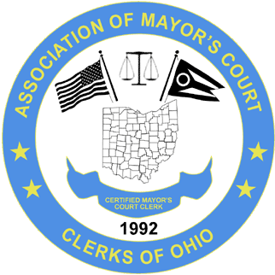 April 23rd – 24th – NATIONWIDE CONFERENCE CENTER
The Association of Mayor’s Court Clerks of Ohio
2026 Spring Conference
____________________________________________________________________________________________
AGENDA
WEDNESDAY April 22
6:00 P.M. Board Meeting

April 23rd – 24th – NATIONWIDE CONFERENCE CENTER
The Association of Mayor’s Court Clerks of Ohio
2026 Spring Conference
___________________________________________________________________________________________
AGENDA
THURSDAY APRIL 23

7:30 A.M. Breakfast & Networking
8:30 A.M. New Clerks Meeting

8:30 A.M. Welcome

8:45 A.M. Business Meeting
9:00 A.M. Chris Geocaris – Deputy Director Supreme Court of Ohio

10:30 AM Break/Visit Vendors - Foyer
11:00 A.M. 1n5 – Mental Health

12:00 P.M. Lunch

1:30 P.M. Legal Updates - Steven Smith
3:30 P.M. Break
3:45 P.M. SOCF - Drugs Getting Into Prisons

5:00 P.M. Closing Remarks

April 23rd – 24th – NATIONWIDE CONFERENCE CENTER
The Association of Mayor’s Court Clerks of Ohio
2026 Spring Conference
__________________________________________________________________________________________
FRIDAY APRIL 24

7:30 A.M. Breakfast & Networking
8:30 A.M. Welcome

8:30 A.M. Roundtables

10:00 A.M. Break/Visit Vendors - Foyer

10:30 A.M. BMV - Updates

12:00 P.M. Closing Statement

