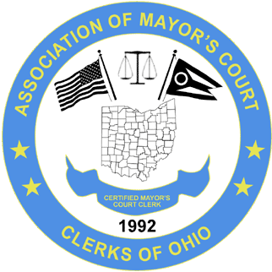

ASSOCIATION OF MAYOR’S COURT CLERKS OF OHIO
www.ohiomayorscourtclerks.org
SPRING SEMINAR APRIL 22 – 24, 2026
Nationwide Hotel and Conference Center
100 Green Meadows Drive
Lewis Center, Ohio, 43035
(614) 880-4167

REGISTRATION INFORMATION

NAME: ________________________________________________________________________

COURT: _______________________________________________ REGION: __________

ADDRESS: _____________________________________________________________________

CITY: ____________________________________ STATE: __________ ZIP: ______________

TELEPHONE: ____________________________________ FAX: __________________________

EMAIL: ________________________________________________________________________

REGISTRATION DEADLINE: APRIL 15, 2026

____ Active Member $200

____ Non Member $300

Make checks payable to: A.M.C.C.O.

Send registration payment to: MONTGOMERY MAYOR’S COURT
JA’NET CRAWFORD
10150 MONTGOMERY RD
MONTGOMERY, OH 45242
jcrawford@montgomeryohio.org
513-985-1606

